# Mobile App Testing

**Some of test cases in mobile app:**

1. **Installation and Launch Testing**

One of the fundamental aspects of mobile app testing is ensuring that the application can be installed and launched successfully. Here are some sample test cases for installation and launch testing:

* Verify that the app can be installed without any errors or crashes on different devices and operating systems.
* Test the app’s behavior during installation interruptions such as low battery, network failure, or incoming calls.
* Validate that the app launches within a reasonable time frame and displays the expected splash screen or loading indicators.
* Check if the app handles app permissions correctly and requests necessary permissions when required.



1. **Functionality Testing**

Functionality testing is essential to ensure that the app performs as intended and meets the user’s requirements. Here are some sample test cases for functionality testing:

* Test all the app features and functionalities, ensuring they work as expected and provide the desired outcomes.
* Validate input fields, buttons, checkboxes, and other interactive elements for proper functionality.
* Verify that the app handles various scenarios, such as offline mode, low memory, and multitasking.
* Test the integration of external services or APIs to ensure seamless communication and data exchange.

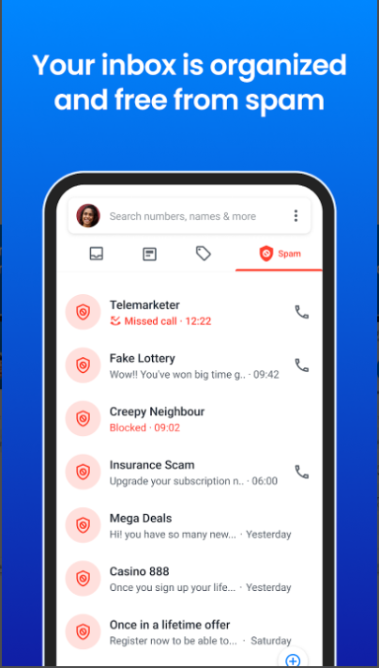

1. **User Interface and User Experience Testing**

User interface and user experience are crucial factors for the success of a mobile app. Here are some sample test cases for UI and UX testing:

* Test the app’s layout and design on different screen sizes, resolutions, and orientations to ensure responsiveness and adaptability.
* Validate that all UI elements, such as buttons, icons, and images, are displayed correctly and aligned properly.
* Check if the app follows consistent navigation patterns, such as back buttons, menus, and gestures, across different screens.
* Ensure that the app provides clear and concise error messages or notifications to guide users in case of any issues or failures.

1. **Performance Testing**

Performance testing helps assess the app’s responsiveness, speed, and stability under different conditions. Here are some sample test cases for performance testing:

* Test the app’s loading time, response time, and overall performance on devices with varying specifications.
* Simulate heavy usage scenarios, such as concurrent user access, to check for any performance degradation or bottlenecks.
* Validate that the app’s memory usage is optimized and does not consume excessive resources, leading to device slowdowns or crashes.
* Test the app’s behavior during extended usages, such as battery consumption, overheating, or excessive data usage.

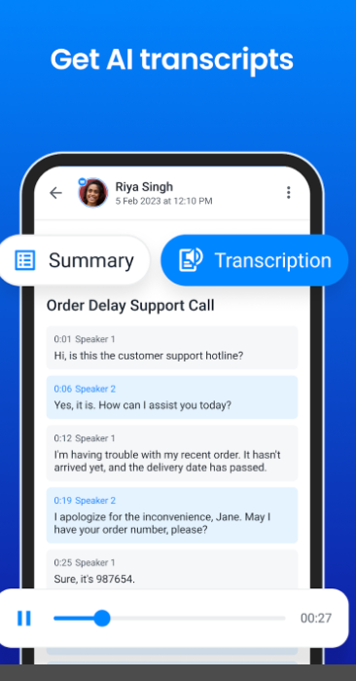

**5. Security Testing**

Security is a critical aspect of mobile app testing, especially considering the sensitive user data and interactions involved. Here are some sample test cases for security testing:

* Validate that the app encrypts and securely stores user credentials, passwords, and personal information.
* Test the app’s resistance to common security threats, such as SQL injection, cross-site scripting (XSS), and session hijacking.
* Check if the app enforces proper authentication and authorization mechanisms to prevent unauthorized access to sensitive functionalities or data.
* Test the app’s behavior during scenarios like app tampering or installation from unofficial sources.

